1. **Implement A* Search algorithm.**

def aStarAlgo(start_node, stop_node):

open_set = set(start_node)

closed_set = set()

g = {} #store distance from starting node

parents = {} # parents contains an adjacency map of all nodes

#distance of starting node from itself is zero

g[start_node] = 0

#start_node is root node i.e it has no parent nodes

#so start_node is set to its own parent node

parents[start_node] = start_node

while len(open_set) > 0:

n = None

#node with lowest f() is found

for v in open_set:

if n == None or g[v] + heuristic(v) < g[n] + heuristic(n):

n = v

if n == stop_node or Graph_nodes[n] == None:

pass

else:

for (m, weight) in get_neighbors(n):

#nodes 'm' not in first and last set are added to first

#n is set its parent

if m not in open_set and m not in closed_set:

open_set.add(m)

parents[m] = n

g[m] = g[n] + weight

#for each node m,compare its distance from start i.e g(m) to the

#from start through n node

else:

if g[m] > g[n] + weight:

#update g(m)

g[m] = g[n] + weight

#change parent of m to n

parents[m] = n

#if m in closed set,remove and add to open

if m in closed_set:

closed_set.remove(m)

open_set.add(m)

if n == None:

print('Path does not exist!')

return None

# if the current node is the stop_node

# then we begin reconstructin the path from it to the start_node

if n == stop_node:

path = []

while parents[n] != n:

path.append(n)

n = parents[n]

path.append(start_node)

path.reverse()

print('Path found: {}'.format(path))

return path

# remove n from the open_list, and add it to closed_list

# because all of his neighbors were inspected

open_set.remove(n)

closed_set.add(n)

print('Path does not exist!')

return None

#define fuction to return neighbor and its distance

#from the passed node

def get_neighbors(v):

if v in Graph_nodes:

return Graph_nodes[v]

else:

return None

#for simplicity we ll consider heuristic distances given

#and this function returns heuristic distance for all nodes

def heuristic(n):

H_dist = {

'A': 11,

'B': 6,

'C': 5,

'D': 7,

'E': 3,

'F': 6,

'G': 5,

'H': 3,

'I': 1,

'J': 0

}

return H_dist[n]

#Describe your graph here

Graph_nodes = {

'A': [('B', 6), ('F', 3)],

'B': [('A', 6), ('C', 3), ('D', 2)],

'C': [('B', 3), ('D', 1), ('E', 5)],

'D': [('B', 2), ('C', 1), ('E', 8)],

'E': [('C', 5), ('D', 8), ('I', 5), ('J', 5)],

'F': [('A', 3), ('G', 1), ('H', 7)],

'G': [('F', 1), ('I', 3)],

'H': [('F', 7), ('I', 2)],

'I': [('E', 5), ('G', 3), ('H', 2), ('J', 3)],

}

aStarAlgo('A', 'J')

**OUTPUT**

Path found: ['A', 'F', 'G', 'I', 'J']

1. **Implement AO* Search algorithm.**

class Graph:

def __init__(self, graph, heuristicNodeList, startNode): #instantiate graph object with graph topology, heuristic values, start node

self.graph = graph

self.H=heuristicNodeList

self.start=startNode

self.parent={}

self.status={}

self.solutionGraph={}

def applyAOStar(self): # starts a recursive AO* algorithm

self.aoStar(self.start, False)

def getNeighbors(self, v): # gets the Neighbors of a given node

return self.graph.get(v,'')

def getStatus(self,v): # return the status of a given node

return self.status.get(v,0)

def setStatus(self,v, val): # set the status of a given node

self.status[v]=val

def getHeuristicNodeValue(self, n):

return self.H.get(n,0) # always return the heuristic value of a given node

def setHeuristicNodeValue(self, n, value):

self.H[n]=value # set the revised heuristic value of a given node

def printSolution(self):

print("FOR GRAPH SOLUTION, TRAVERSE THE GRAPH FROM THE START NODE:",self.start)

print("------------------------------------------------------------")

print(self.solutionGraph)

print("------------------------------------------------------------")

def computeMinimumCostChildNodes(self, v): # Computes the Minimum Cost of child nodes of a given node v

minimumCost=0

costToChildNodeListDict={}

costToChildNodeListDict[minimumCost]=[]

flag=True

for nodeInfoTupleList in self.getNeighbors(v): # iterate over all the set of child node/s

cost=0

nodeList=[]

for c, weight in nodeInfoTupleList:

cost=cost+self.getHeuristicNodeValue(c)+weight

nodeList.append(c)

if flag==True: # initialize Minimum Cost with the cost of first set of child node/s

minimumCost=cost

costToChildNodeListDict[minimumCost]=nodeList # set the Minimum Cost child node/s

flag=False

else: # checking the Minimum Cost nodes with the current Minimum Cost

if minimumCost>cost:

minimumCost=cost

costToChildNodeListDict[minimumCost]=nodeList # set the Minimum Cost child node/s

return minimumCost, costToChildNodeListDict[minimumCost] # return Minimum Cost and Minimum Cost child node/s

def aoStar(self, v, backTracking): # AO* algorithm for a start node and backTracking status flag

print("HEURISTIC VALUES :", self.H)

print("SOLUTION GRAPH :", self.solutionGraph)

print("PROCESSING NODE :", v)

print("-----------------------------------------------------------------------------------------")

if self.getStatus(v) >= 0: # if status node v >= 0, compute Minimum Cost nodes of v

minimumCost, childNodeList = self.computeMinimumCostChildNodes(v)

print(minimumCost, childNodeList)

self.setHeuristicNodeValue(v, minimumCost)

self.setStatus(v,len(childNodeList))

solved=True # check the Minimum Cost nodes of v are solved

for childNode in childNodeList:

self.parent[childNode]=v

if self.getStatus(childNode)!=-1:

solved=solved & False

if solved==True: # if the Minimum Cost nodes of v are solved, set the current node status as solved(-1)

self.setStatus(v,-1)

self.solutionGraph[v]=childNodeList # update the solution graph with the solved nodes which may be a part of solution

if v!=self.start: # check the current node is the start node for backtracking the current node value

self.aoStar(self.parent[v], True) # backtracking the current node value with backtracking status set to true

if backTracking==False: # check the current call is not for backtracking

for childNode in childNodeList: # for each Minimum Cost child node

self.setStatus(childNode,0) # set the status of child node to 0(needs exploration)

self.aoStar(childNode, False) # Minimum Cost child node is further explored with backtracking status as false

#for simplicity we ll consider heuristic distances given

print ("Graph - 1")

h1 = {'A': 1, 'B': 6, 'C': 2, 'D': 12, 'E': 2, 'F': 1, 'G': 5, 'H': 7, 'I': 7, 'J': 1}

graph1 = {

'A': [[('B', 1), ('C', 1)], [('D', 1)]],

'B': [[('G', 1)], [('H', 1)]],

'C': [[('J', 1)]],

'D': [[('E', 1), ('F', 1)]],

'G': [[('I', 1)]]

}

G1= Graph(graph1, h1, 'A')

G1.applyAOStar()

G1.printSolution()

**OUTPUT**

Graph - 1

HEURISTIC VALUES : {'A': 1, 'B': 6, 'C': 2, 'D': 12, 'E': 2, 'F': 1, 'G': 5, 'H': 7, 'I': 7, 'J': 1}

SOLUTION GRAPH : {}

PROCESSING NODE : A

-----------------------------------------------------------------------------------------

10 ['B', 'C']

HEURISTIC VALUES : {'A': 10, 'B': 6, 'C': 2, 'D': 12, 'E': 2, 'F': 1, 'G': 5, 'H': 7, 'I': 7, 'J': 1}

SOLUTION GRAPH : {}

PROCESSING NODE : B

-----------------------------------------------------------------------------------------

6 ['G']

HEURISTIC VALUES : {'A': 10, 'B': 6, 'C': 2, 'D': 12, 'E': 2, 'F': 1, 'G': 5, 'H': 7, 'I': 7, 'J': 1}

SOLUTION GRAPH : {}

PROCESSING NODE : A

-----------------------------------------------------------------------------------------

10 ['B', 'C']

HEURISTIC VALUES : {'A': 10, 'B': 6, 'C': 2, 'D': 12, 'E': 2, 'F': 1, 'G': 5, 'H': 7, 'I': 7, 'J': 1}

SOLUTION GRAPH : {}

PROCESSING NODE : G

-----------------------------------------------------------------------------------------

8 ['I']

HEURISTIC VALUES : {'A': 10, 'B': 6, 'C': 2, 'D': 12, 'E': 2, 'F': 1, 'G': 8, 'H': 7, 'I': 7, 'J': 1}

SOLUTION GRAPH : {}

PROCESSING NODE : B

-----------------------------------------------------------------------------------------

8 ['H']

HEURISTIC VALUES : {'A': 10, 'B': 8, 'C': 2, 'D': 12, 'E': 2, 'F': 1, 'G': 8, 'H': 7, 'I': 7, 'J': 1}

SOLUTION GRAPH : {}

PROCESSING NODE : A

-----------------------------------------------------------------------------------------

12 ['B', 'C']

HEURISTIC VALUES : {'A': 12, 'B': 8, 'C': 2, 'D': 12, 'E': 2, 'F': 1, 'G': 8, 'H': 7, 'I': 7, 'J': 1}

SOLUTION GRAPH : {}

PROCESSING NODE : I

-----------------------------------------------------------------------------------------

0 []

HEURISTIC VALUES : {'A': 12, 'B': 8, 'C': 2, 'D': 12, 'E': 2, 'F': 1, 'G': 8, 'H': 7, 'I': 0, 'J': 1}

SOLUTION GRAPH : {'I': []}

PROCESSING NODE : G

-----------------------------------------------------------------------------------------

1 ['I']

HEURISTIC VALUES : {'A': 12, 'B': 8, 'C': 2, 'D': 12, 'E': 2, 'F': 1, 'G': 1, 'H': 7, 'I': 0, 'J': 1}

SOLUTION GRAPH : {'I': [], 'G': ['I']}

PROCESSING NODE : B

-----------------------------------------------------------------------------------------

2 ['G']

HEURISTIC VALUES : {'A': 12, 'B': 2, 'C': 2, 'D': 12, 'E': 2, 'F': 1, 'G': 1, 'H': 7, 'I': 0, 'J': 1}

SOLUTION GRAPH : {'I': [], 'G': ['I'], 'B': ['G']}

PROCESSING NODE : A

-----------------------------------------------------------------------------------------

6 ['B', 'C']

HEURISTIC VALUES : {'A': 6, 'B': 2, 'C': 2, 'D': 12, 'E': 2, 'F': 1, 'G': 1, 'H': 7, 'I': 0, 'J': 1}

SOLUTION GRAPH : {'I': [], 'G': ['I'], 'B': ['G']}

PROCESSING NODE : C

-----------------------------------------------------------------------------------------

2 ['J']

HEURISTIC VALUES : {'A': 6, 'B': 2, 'C': 2, 'D': 12, 'E': 2, 'F': 1, 'G': 1, 'H': 7, 'I': 0, 'J': 1}

SOLUTION GRAPH : {'I': [], 'G': ['I'], 'B': ['G']}

PROCESSING NODE : A

-----------------------------------------------------------------------------------------

6 ['B', 'C']

HEURISTIC VALUES : {'A': 6, 'B': 2, 'C': 2, 'D': 12, 'E': 2, 'F': 1, 'G': 1, 'H': 7, 'I': 0, 'J': 1}

SOLUTION GRAPH : {'I': [], 'G': ['I'], 'B': ['G']}

PROCESSING NODE : J

-----------------------------------------------------------------------------------------

0 []

HEURISTIC VALUES : {'A': 6, 'B': 2, 'C': 2, 'D': 12, 'E': 2, 'F': 1, 'G': 1, 'H': 7, 'I': 0, 'J': 0}

SOLUTION GRAPH : {'I': [], 'G': ['I'], 'B': ['G'], 'J': []}

PROCESSING NODE : C

-----------------------------------------------------------------------------------------

1 ['J']

HEURISTIC VALUES : {'A': 6, 'B': 2, 'C': 1, 'D': 12, 'E': 2, 'F': 1, 'G': 1, 'H': 7, 'I': 0, 'J': 0}

SOLUTION GRAPH : {'I': [], 'G': ['I'], 'B': ['G'], 'J': [], 'C': ['J']}

PROCESSING NODE : A

-----------------------------------------------------------------------------------------

5 ['B', 'C']

FOR GRAPH SOLUTION, TRAVERSE THE GRAPH FROM THE START NODE: A

------------------------------------------------------------

{'I': [], 'G': ['I'], 'B': ['G'], 'J': [], 'C': ['J'], 'A': ['B', 'C']}

------------------------------------------------------------

1. **For a given set of training data examples stored in a CSV file, implement and demonstrate the Candidate-Elimination algorithm to output a description of the set of all hypotheses consistent with the training examples.**

import numpy as np

import pandas as pd

*# the csv file used here is enjoysport.csv stored in the Anaconda installed folder*

data = pd.read_csv(*'enjoysport.csv'*)

concepts = np.array(data.iloc[:,0:-1])

print("\nInstances are:\n",concepts)

target = np.array(data.iloc[:,-1])

print("\nTarget Values are: ",target)

def learn(concepts, target):

specific_h = concepts[0].copy()

print("\nInitialization of specific_h and genearal_h")

print("\nSpecific Boundary: ", specific_h)

general_h = [["?" for i in range(len(specific_h))] for i in range(len(specific_h))]

print("\nGeneric Boundary: ",general_h)

for i, h in enumerate(concepts):

print("\nInstance", i+1 , "is ", h)

if target[i] == "yes":

print("Instance is Positive ")

for x in range(len(specific_h)):

if h[x]!= specific_h[x]:

specific_h[x] ='?'

general_h[x][x] ='?'

if target[i] == "no":

print("Instance is Negative ")

for x in range(len(specific_h)):

if h[x]!= specific_h[x]:

general_h[x][x] = specific_h[x]

else:

general_h[x][x] = '?'

print("Specific Bundary after ", i+1, "Instance is ", specific_h)

print("Generic Boundary after ", i+1, "Instance is ", general_h)

print("\n")

indices = [i for i, val in enumerate(general_h) if val == ['?', '?', '?', '?', '?', '?']]

for i in indices:

general_h.remove(['?', '?', '?', '?', '?', '?'])

return specific_h, general_h

s_final, g_final = learn(concepts, target)

print("Final Specific_h: ", s_final, sep="\n")

print("Final General_h: ", g_final, sep="\n")

**OUTPUT**

Instances are:

[['sunny' 'warm' 'normal' 'strong' 'warm' 'same']

['sunny' 'warm' 'high' 'strong' 'warm' 'same']

['rainy' 'cold' 'high' 'strong' 'warm' 'change']

['sunny' 'warm' 'high' 'strong' 'cool' 'change']]

Target Values are: ['yes' 'yes' 'no' 'yes']

Initialization of specific_h and genearal_h

Specific Boundary: ['sunny' 'warm' 'normal' 'strong' 'warm' 'same']

Generic Boundary: [['?', '?', '?', '?', '?', '?'], ['?', '?', '?', '?', '?', '?'], ['?', '?', '?', '?', '?', '?'], ['?', '?', '?', '?', '?', '?'], ['?', '?', '?', '?', '?', '?'], ['?', '?', '?', '?', '?', '?']]

Instance 1 is ['sunny' 'warm' 'normal' 'strong' 'warm' 'same']

Instance is Positive

Specific Bundary after 1 Instance is ['sunny' 'warm' 'normal' 'strong' 'warm' 'same']

Generic Boundary after 1 Instance is [['?', '?', '?', '?', '?', '?'], ['?', '?', '?', '?', '?', '?'], ['?', '?', '?', '?', '?', '?'], ['?', '?', '?', '?', '?', '?'], ['?', '?', '?', '?', '?', '?'], ['?', '?', '?', '?', '?', '?']]

Instance 2 is ['sunny' 'warm' 'high' 'strong' 'warm' 'same']

Instance is Positive

Specific Bundary after 2 Instance is ['sunny' 'warm' '?' 'strong' 'warm' 'same']

Generic Boundary after 2 Instance is [['?', '?', '?', '?', '?', '?'], ['?', '?', '?', '?', '?', '?'], ['?', '?', '?', '?', '?', '?'], ['?', '?', '?', '?', '?', '?'], ['?', '?', '?', '?', '?', '?'], ['?', '?', '?', '?', '?', '?']]

Instance 3 is ['rainy' 'cold' 'high' 'strong' 'warm' 'change']

Instance is Negative

Specific Bundary after 3 Instance is ['sunny' 'warm' '?' 'strong' 'warm' 'same']

Generic Boundary after 3 Instance is [['sunny', '?', '?', '?', '?', '?'], ['?', 'warm', '?', '?', '?', '?'], ['?', '?', '?', '?', '?', '?'], ['?', '?', '?', '?', '?', '?'], ['?', '?', '?', '?', '?', '?'], ['?', '?', '?', '?', '?', 'same']]

Instance 4 is ['sunny' 'warm' 'high' 'strong' 'cool' 'change']

Instance is Positive

Specific Bundary after 4 Instance is ['sunny' 'warm' '?' 'strong' '?' '?']

Generic Boundary after 4 Instance is [['sunny', '?', '?', '?', '?', '?'], ['?', 'warm', '?', '?', '?', '?'], ['?', '?', '?', '?', '?', '?'], ['?', '?', '?', '?', '?', '?'], ['?', '?', '?', '?', '?', '?'], ['?', '?', '?', '?', '?', '?']]

Final Specific_h:

['sunny' 'warm' '?' 'strong' '?' '?']

Final General_h:

[['sunny', '?', '?', '?', '?', '?'], ['?', 'warm', '?', '?', '?', '?']]

1. **Write a program to demonstrate the working of the decision tree based ID3 algorithm. Use an appropriate data set for building the decision tree and apply this knowledge to classify a new sample.**

from sklearn.tree import DecisionTreeClassifier

from sklearn import datasets

from sklearn import tree

from graphviz import Digraph

import pydotplus

import matplotlib.pyplot as plt

import matplotlib.image as pltimg

*# The dataset used here is iris.csv stored in the anaconda installed folder*

iris=datasets.load_iris()

X=iris.data

Y=iris.target

print(iris.target_names,iris.feature_names)

clf=DecisionTreeClassifier(criterion="entropy")

model=clf.fit(X,Y)

dot_data=tree.export_graphviz(clf,out_file=None,class_names=iris.target_names)

graph=pydotplus.graph_from_dot_data(dot_data)

graph.write_png("tree.jpg")

img=pltimg.imread('tree.jpg')

imgplot = plt.imshow(img)

plt.show()

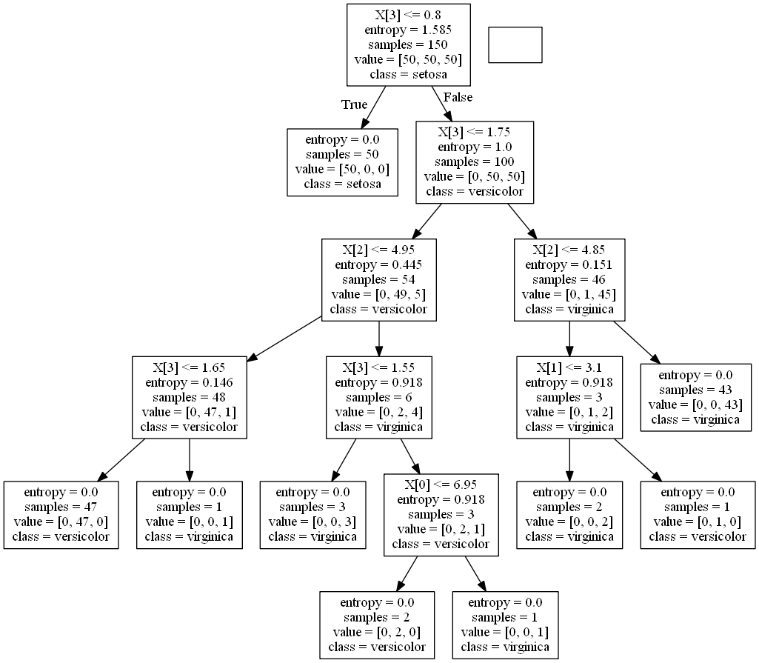

1. **Build an Artificial Neural Network by implementing the Backpropagation algorithm and test the same using appropriate data sets.**

import numpy as np

X=np.array(([2,9],[1,5],[3,6]),dtype=float)

y=np.array(([92],[82],[89]),dtype=float)

X=X/np.amax(X,axis=0)

y=y/100

def sigmoid(x):

return 1/(1+np.exp(-x))

def derivatives_sigmoid(x):

return x*(1-x)

epoch=7000

lr=0.1

inputlayer_neurons=2

hiddenlayer_neurons=3

output_neurons=1

wh=np.random.uniform(size=(inputlayer_neurons,hiddenlayer_neurons))

bh=np.random.uniform(size=(1,hiddenlayer_neurons))

wout=np.random.uniform(size=(hiddenlayer_neurons,output_neurons))

bout=np.random.uniform(size=(1,output_neurons))

for i in range(epoch):

hinp1=np.dot(X,wh)

hinp=hinp1+bh

hlayer_act=sigmoid(hinp)

outinp1=np.dot(hlayer_act,wout)

outinp=outinp1+bout

output=sigmoid(outinp)

EO=y-output

outgrad=derivatives_sigmoid(output)

d_output=EO*outgrad

EH=d_output.dot(wout.T)

hiddengrad=derivatives_sigmoid(hlayer_act)

d_hiddenlayer=EH*hiddengrad

wout+=hlayer_act.T.dot(d_output)*lr

wh+=X.T.dot(d_hiddenlayer)*lr

print("Input:\n"+str(X))

print("actualn output:\n"+str(y))

print("predicted output: \n",output)

**OUTPUT**

Input:

[[0.66666667 1. ]

[0.33333333 0.55555556]

[1. 0.66666667]]

actual output:

[[0.92]

[0.82]

[0.89]]

predicted output:

[[0.88090309]

[0.86524657]

[0.88343488]]

1. **Write a program to implement the naïve Bayesian classifier for a sample training data set stored as a .CSV file. Compute the accuracy of the classifier, considering few test data sets.**

from sklearn import datasets

from sklearn import metrics

from sklearn.naive_bayes import MultinomialNB

*# The dataset used here is iris.csv stored in the anaconda installed folder*

dataset=datasets.load_iris()

model=MultinomialNB()

model.fit(dataset.data,dataset.target)

expected=dataset.target

predected=model.predict(dataset.data)

print(metrics.accuracy_score(expected,predected))

print(metrics.confusion_matrix(expected,predected))

**OUTPUT**

0.9533333333333334

[[50 0 0]

[ 0 46 4]

[ 0 3 47]]

1. **Apply EM algorithm to cluster a set of data stored in a .CSV file. Use the same data set for clustering using k-Means algorithm. Compare the results of these two algorithms and comment on the quality of clustering. You can add Java/Python ML library classes/API in the program.**

from sklearn.cluster import KMeans

import pandas as pd

import numpy as np

import matplotlib.pyplot as plt

*# The dataset used here is a.csv stored in the anaconda installed folder*

data=pd.read_csv("a.csv")

x1=data['x'].values

x2=data['y'].values

print(data)

x=np.matrix(list(zip(x1,x2)))

plt.scatter(x1,x2)

plt.show()

markers=['s','o','v']

k=3

clusters=KMeans(n_clusters=k).fit(x)

for i,L in enumerate(clusters.labels_):

plt.plot(x1[i],x2[i],marker=markers[L])

**OUTPUT**

x y

0 1 12.0

1 1 3.0

2 11 23.0

3 2 5.0

4 3 6.0

5 12 57.0

6 65 25.0

7 12 45.9

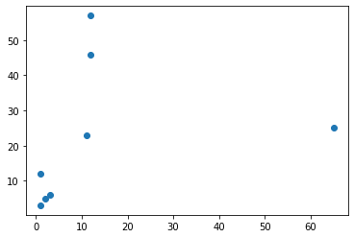

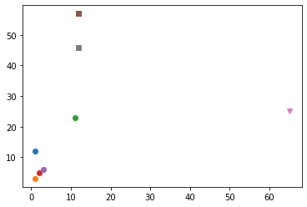

1. **Write a program to implement k-Nearest Neighbour algorithm to classify the iris data set. Print both correct and wrong predictions. Java/Python ML library classes can be used for this problem.**

from sklearn.model_selection import train_test_split

from sklearn.neighbors import KNeighborsClassifier

from sklearn.metrics import confusion_matrix,classification_report

from sklearn import datasets

*# The dataset used here is iris.csv stored in the anaconda installed folder*

iris=datasets.load_iris()

iris_data=iris.data

iris_labels=iris.target

#print(iris_data)

x_train,X_test,y_train,Y_test = train_test_split(iris_data,iris_labels,test_size=0.20)

classifier=KNeighborsClassifier(n_neighbors=5)

classifier.fit(x_train,y_train)

y_prd=classifier.predict(X_test)

print(confusion_matrix(Y_test,y_prd))

print(classification_report(Y_test,y_prd))

**OUTPUT**

[[10 0 0]

[ 0 8 1]

[ 0 2 9]]

precision recall f1-score support

0 1.00 1.00 1.00 10

1 0.80 0.89 0.84 9

2 0.90 0.82 0.86 11

accuracy 0.90 30

macro avg 0.90 0.90 0.90 30

weighted avg 0.90 0.90 0.90 30

1. **Implement the non-parametric Locally Weighted Regression algorithm in order to fit data points. Select appropriate data set for your experiment and draw graphs**

from numpy import *

import operator

from os import listdir

import matplotlib

import matplotlib.pyplot as plt

import pandas as pd

import numpy.linalg

from scipy.stats.stats import pearsonr

def kernel(point,xmat,k):

m,n=shape(xmat)

weights=mat(eye((m)))

for j in range(m):

diff=point-X[j]

weights[j,j]=exp(diff*diff.T/(-2.0*k**2))

return weights

def localWeight(point,xmat,ymat,k):

wei=kernel(point,xmat,k)

W=((X.T*wei*X)).I*(X.T*(wei*ymat.T))

return W

def localWeightRegression(xmat,ymat,k):

m,n=shape(xmat)

ypred=zeros(m)

for i in range(m):

ypred [i]=xmat[i]*localWeight(xmat[i],xmat,ymat,k)

return ypred

*# The dataset used here is tips.csv stored in the anaconda installed folder*

data=pd.read_csv('tips.csv')

bill=array(data.t_bill)

tip=array(data.tip)

mbill=mat(bill)

mtip=mat(tip)

m=shape(mbill)[1]

one=mat(ones(m))

X=hstack((one.T,mbill.T))

ypred=localWeightRegression(X,mtip,0.5)

SortIndex=X[:,1].argsort(0)

xsort=X[SortIndex][:,0]

fig=plt.figure()

ax=fig.add_subplot(1,1,1)

ax.scatter(bill,tip,color='green')

ax.plot(xsort[:,1],ypred[SortIndex],color='red',linewidth=5)

plt.xlabel('bill')

plt.ylabel('tip')

plt.show();

**OUTPUT**

